06th September 2017

**FIA European Touring Car Cup resumes in Zolder Belgium**

The FIA European Touring Car Cup – ETCC which boasts the Japanese premium tyre manufacturer YOKOHAMA as Official Tyre supplier, resumes in Zolder, Belgium from the 15th-17th September with the veteran Petr Fulin ahead of the pack.

With a lead of 13 points after eight races and another four races still offering plenty of points to be grabbed, the Czech Seat driver will have strong competition from his immediate competitors, Honda’s Christjohannes Schreiber from Switzerland, as well as the Hungarian Norbert Nagy and the Macedonian Igor Stefanovski.

The closing four rounds of the season will be hard fought in Belgium tarmac and this will be followed by the race in Autodrom Most, one hour north of Prague in the Czech Republic from 6th -8th October.

A spokesman for YOKOHAMA expressed satisfaction with the season so far and wished the competitors good luck ahead of the intense racing ahead. “There is a narrow lead at the top and everyone will be pushing hard, our Motorsport support team, will assist as always to ensure everyone gets a fair chance and offer all the tyre technical advice to ensure high performance and safety, depending on the conditions on the day.” He concluded.

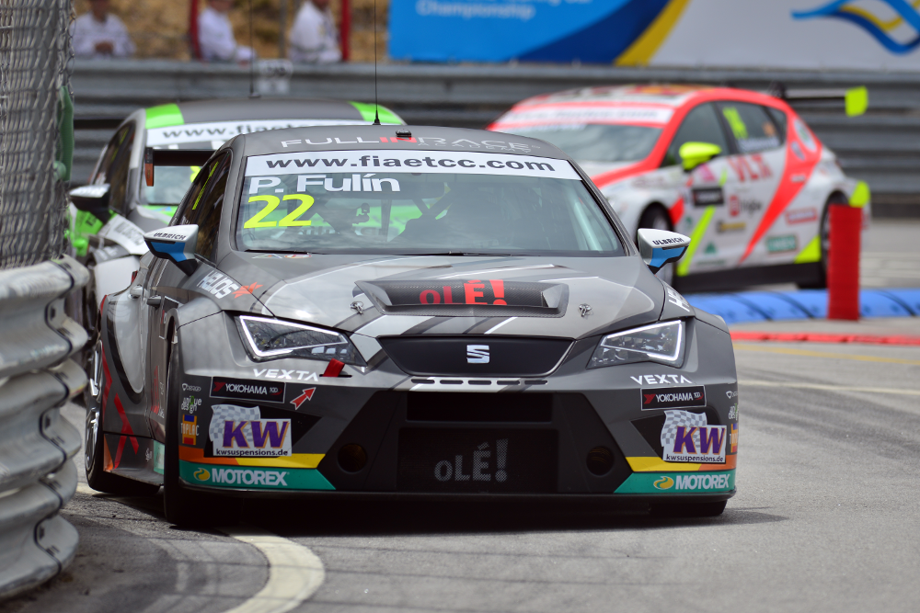

*Petr Fulin leads the FIA ETCC*

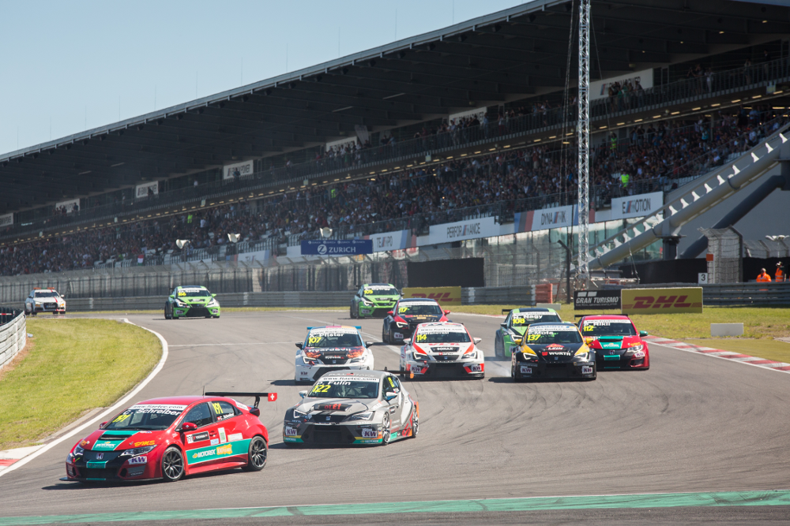

*ETCC tough competition expected in Zolder*